ANAST – UNIVERSITE DE LIEGE

LBR-5

OPTIMIZATION D’UN VLCC

&

DETAILS DES PARAMETRES
DE LA FONCTION OBJECTIF COUT

Le 30 Août 2001 – St. Nazaire, France
In the present example the global building cost is evaluated using the following costs and productivity factors:

- Reference plate thickness = 20 mm,

- K = Unitary Labor Cost($/m-h)/Material Cost($/t)
= 0.08 (in US) or 0.03 (in Korea)

- Unitary price of steel: C1 = 0.50 $/kg,

- Unitary price of welding (materials only): C8 = 2.00 $/m,

- Unitary working load (labor):
  - Plate assembling: P10 = 0.25 m-h/m²,
  - Welding stiffeners on the panel: P4 = 0.5m-h/m,
  - Welding frames on the panel: P5 = 1.5 m-h/m,
  - Built the members: (if built on site), P9=1.5 m-h/m

otherwise P9 = 0.0 m-h/m,
  - Slot for stiffener: P6 = 0.6 m-h/piece,
  - Bracket and web stiffener: P7 = 0.6 m-h/piece.

PARAMETERS of the COST OBJECTIVE FUNCTION

The cost model, currently used in the LBR-5 model, includes three components.

FC = F_{MAT} + F_{CONS} + F_{ManP} (in Euros) [14]

FC: Global cost function (in Euros);
F_{MAT}: Cost of basic materials (plates, bars, etc);
F_{CONS}: Cost of consumables necessary for the manufacturing process (energy, welding materials, etc.);
F_{ManP}: Cost of manpower used for the construction of the entire structure.

In this section, the current currency is EURO but it can be replaced by $ or any other currency.

- ICOUT Choice the objective function type: Weight or Cost
Format : 1 INTEGER ; 1 line free format

ICOUT = 0 a Minimal Weight objective function is selected,
ICOUT = 1 a Minimal Cost objective function is selected
Note that the weight is also considered in the Cost Model (see Eq.14).

- REND, EQP Shipyard efficiency and EQP ratio

Format : 2 REAL (free format) , Example : 1.00 0.01 User comment

REND = Efficiency parameter to characterize the yard production (for sensitivity analysis), (0.00 < REND <1.00)
In principle, it is recommended to select REND=1.00.
The ‘REND’ parameter is used to assess the impact of the yard efficiency on the optimum solution. It only affect the cost of manpower (F_{ManP}) used for the construction of the structure (Eq.14). It does not concern the material cost (F_{MAT}) and the consumable costs necessary the manufacturing process (F_{CONS}). So, changing ‘REND’ can change the optimum solution.
‘REND’ has an effect on the ‘P4, P5, P6, P7, P9 and P10’parameters (see here after).

EQP = Weight Equivalent Parameter (ton/m-h)



0.005 < EQP < 0.2 ton/m-h for steel structure

Low value of EQP drives the optimum solution to least weight structure (as the cost is in that case mainly a matter of weight). On the contrary, high value of EQP drives the solution to reduce the labor work and to induce a higher weight. To consider the impact of the weight on the running cost (operational cost) is could be recommended to reduce the theoretical EQP. So, the relative importance of the weight versus to the cost is increased.

For steel: (1 ton is estimated to 3600 FF, 550 Euro in Europe , 500$ in USA)
EQP = 0.005 to 0.02 in low developing countries (2.5 Euro/m-h),
EQP = 0.05 to 0.20 in Europe (35 to 50 Euro/m-h)

For aluminum: (1 ton is estimated to 2500 Euro in Europe)
EQP = 0.001 to 0.004 in low developing countries (2.5 Euro/m-h),
EQP = 0.01 to 0.04 in Europe (35 to 50 Euro/m-h)

- Dref (or Eo)
Reference thickness (of the plate) to be defined by the user (in m) based on the mean plate thickness (ex.: 0.01 m for a plate of 10-mm thick).
Format: 1 REAL ; 1 line free format ex.: 0.012 Dref

This reference plate thickness (Dref or Eo) is associated with several cost parameters, which are changing with plate thickness.
These parameters are:
- C1, C2, C3 (Euro/kg), cost per kg of material;
- C8 (Euro/m,) cost of consumables;
- P4,P5,P9 and P10, working loads.

MATERIAL COST : Fmat

The cost of materials is directly derived from the weight function. Each term is multiplied by the relevant C_{i} unitary material cost (plate, bar,...). Thus, one gets:
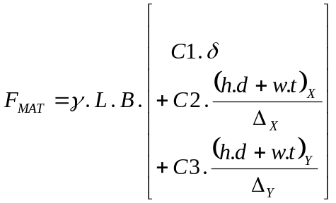 (Euro) [15]

with C1 = cost per kg of a plate δ mm thick,
C2 = cost per kg of the longitudinals/stiffeners,
C3 = cost per kg of the transverse frames.

and
L = length of the panel according to the X co-ordinate (m),
B = breadth of the panel according to the Y co-ordinate (m),
δ = plate thickness (m),
γ = specific weight (N/m³),
(h,d,w,t)_{X} = dimensions of web and flange of the longitudinals/stiffeners fitted along X,
(h,d,w,t)_{Y} = dimensions of web and flange of the transverse frames fitted along Y,
Δ_{X} = spacing between two longitudinals/stiffeners fitted along X,
Δ_{Y} = spacing between two transverse frames fitted along Y,

- C1, DC1, DC2, and DC3 Material Cost (Euro/kg)

C1(plate, Euro/kg) ,
DC1(plate, 1/mm), DC2(stiffener, 1/mm), DC3(frame, 1/mm)

Format: 4 REAL ; 1 line free format
Ex: 0.05 0.0005 -0.10 -0.10 User comment

In order to take into account of the unitary price variation of the plates (cost per kg) according to their thickness, the parameter C1 is defined as follows:

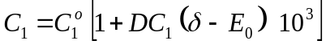 (Euro/kg) [16]

with C1º = cost per kg of a plate with a thickness δ = Eo,
Eo = Dref = reference thickness (of the plate), to be defined by the user (in m),
DC1 = relative change of C1º (cost/kg) between plates of Eo and Eo +1 mm thick.
DC1 can be positive or a negative.

C1 = Belgium : 23 FB/kg (for mild steel AE 235)

25 FB/kg (for HTS AE355)

MILD STEEL HTS

Europe : 0.55 Euro/kg 0.61 Euro/kg
USA 0.50 $/kg 0.55 $ /kg

DC1 = -0.006 according to Th. Van Frachem
(this means 0.6% per mm)

In order to take into account the difference between the price of plates and the price of standard profiled members [IPE, HEA,...], the C2 and C3 coefficients are defined as:

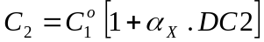 (Euro/kg) for longitudinals/stiffeners, girders and cross-bars
[17]
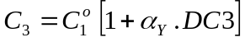 (Euro/kg) for frames and transversal stiffeners.

With
α_{X}, α_{Y} = 0, if the members are manufactured on the yard from standard plates. In this case, the welding costs are considered separately (see the P9 coefficient);
α_{X}, α_{Y} = 1, if the members are standard profiled members [IPE, HEA,...];
DC2, DC3 = relative change of the unitary cost (Euro/kg) for standard profiled longitudinals and for standard profiled frames by comparison to the unitary cost of the reference plate (C1º) , (DC2, DC3 > 0 or <0).

DC2 = -0.10 per mm in Belgium according to Van Frachem (this means 10% less for standard profiles)
= +0.25 in Bengladesh according to Rahman (this means 25% more for standard profiles)
DC3 = -0.10 per mm in Belgium according to Van Frachem (this means 10% less for standard profiles)
= +0.40 in Bengladesh according to Rahman (this means 40% more for standard profiles)

MANPOWER COST : F_{ManP} and WORKING LOAD : ManP

The total Manpower cost (F_{ManP}) to build a stiffened panel is :

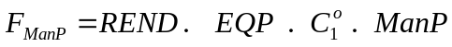 [20]

with ManP = the global working load (man-hours) (Eq. 21).

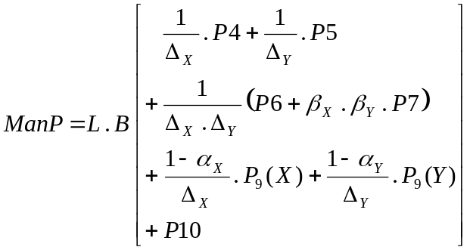 [21]

with P4= working load to weld 1 meter of a longitudinal stiffener on the plating (side shell,...) (m-h/m)
= 0.6 to 1.2 m-h/m;
P5 = working load to weld 1 meter of a transversal stiffener on the plating (m-h/m)
= 0.6 to 1.2 m-h/m;
P6 = working load to cut a slot to allow the intersection between a longitudinal and a transversal and to join these members (m-h/intersection).
= 0.2 to 0.6 m-h/intersection;
P7 = working load to fix bracket(s) at the intersection between a longitudinal and a transversal (m-h/intersection).
= 0.3 to 1.2 m-h/intersection;
β_{X},β_{Y}= ratio (in %) of the longitudinal stiffeners (β_{X}) and transverse stiffeners (β_{Y}) that requires brackets (e.g.: β_{X} = 0.33 means one bracketed longitudinal on 3 and β_{Y} = 1.0 a bracket on each frame);
P9 = working load to build 1 meter of stiffener (assembling flange and web) from standard plates in the production plan (m-h/m). Note: If α_{X} and α_{Y} = 1 (Eq.17), P9 is not requested;
P10 = working load to prepare 1 m² of plating (m-h/m²). Generally this working load is linked to plate thickness and the ratio of the half-perimeter of the available plates (a.b) on its surface [(a+b)/(a.b)].
= 0.3 to 1.5 (m-h/m²).
These working loads are defined as follows:

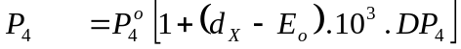 [22]
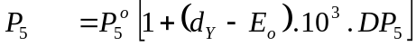
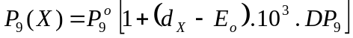
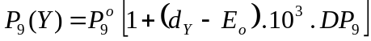

with d_{X}, d_{Y} = web thickness for stiffeners along X and Y;
P₄º, P₅º and P₉º = P4, P5, P9 working loads for the Eo reference plate thickness (m-h/m)
= 0.6 to 1.2 m-h/m;
DP₄, DP₅, DP₉ = relative change, by mm of d, of P₄º, P₅º and P₉º working loads.

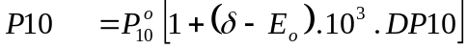 [23]

with δ = plate thickness;
P₁₀º = working load to prepare 1 m² of plating having the Eo reference thickness (m-h/m²).
DP10 = relative change of the P₁₀º working load., per mm of δ (variation between Eo and Eo+1mm)

P10 = Working load to prepare 1 m² of plating having the Eo reference thickness (m-h/m²).
= 1.00 m-h/m² according to Van Frachem (using plates of 6x3m)
= 0.35 m-h/m² (according to Winkle and Baird)
DP10 = Relative change of the P₁₀º working load between using "Dref" plate thickness and "Dref + 1mm"
= +0.07 (7.0%) according to Van Frachem

- P4 (P₄º) , P5 (P₅º) , DP4, DP5
Working load to weld stiffeners and frames on the plating (if standard profile members are not used but built up)

P₄º (m-h/m), P₅º (m-h/m), Working loads
DP4 (relative variation of P₄º per mm of the stiffener web plate thickness)
DP5 (relative variation of P₅º per mm of the frame web plate thickness)
Format: 4 REAL ; 1 line free format Ex.: 0.85 1.05 0.1 0.1

P4 (P₄º) = Working load to weld 1 meter of a longitudinal stiffener on the plating (side shell,...) (m-h/m)
= +1.65 m-h/m for Dref=10mm
+0.90 m-h/m for Dref=5mm according to Van Frachem (Belgium)
= +1.10 m-h/m according to Rahman (Bengladesh)
= +0.90 m-h/m according to Winkle et Baird (UK)
DP4 = Relative variation of P₄º between using a “Dref” thick web plate and using a "Dref + 1mm"
= +0.1 according to Van Frachem (+10%)

P5 (P₅º) = Working load to weld 1 meter of a transversal frame on the plating (side shell,...) (m-h/m)
= +1.65 m-h/m for Dref=10mm
+0.90 m-h/m for Dref=5mm according to Van Frachem (Belgium)
= +1.25 m-h/m according to Rahman (Bengladesh)
= +0.90 m-h/m according to Winkle et Baird (UK)
DP5 = Relative variation of P₅º between a “Dref” thick web plate and a "Dref + 1mm"
= +0.1 according to Van Frachem (+10%)

- Alpha X, Alpha Y, P9, DP9
Working loads for assembling a member

Alpha X (α_{X}), Alpha Y (α_{Y}), P9, DP9
These parameters concern the working load required to built up members from plates. This process requires to weld the flange with the web. This working load is not used if standard profile members are used.
Format: 2 INTEGER, 2 REAL ; 1 line free format
Ex.: 0 0 0.80 0.10 User comment

Alpha X (noted α_{X} in Equations 17 and 21)
= 1 if standard profile members are used for longitudinals. In that case, P9=0 can be given.
= 0 if standard profile members are not used. P9 has to be given.

Alpha Y (noted α_{y} in Equations 17 and 21)
= 1 if standard profile members are used for the transverse frames. In that case, P9=0 can be given.
= 0 if standard profile members are not used. P9 has to be given.
P9 = Working load required to built up a member from plates (per meter). This work requires to weld 1 m of the web on the flange. This working load (m-h/m) has to be given for the ‘Dref’ reference plate thickness (usually the web as thinner than the flange).
= 1.50 (m-h/m) according to Rahman (Bengladesh)
= 0.60 (m-h/m) according to Winkle and Baird (UK)
= 0.50 (m-h/m) according to Van Frachem (Dref = 10mm), in Belgium
DP9 = Relative variation of the P9 working load between using a "Dref" web plate and a "Dref + 1mm" (1/mm)
= +0.1 (or 10%) according to Van Frachem (Dref = 10mm)

Figure 5 gives an idea of the relation between P9 (the working load) and the plate thickness. This figure considers the welding time but does not include the set up, cleaning, transport, break, etc. So the P9 work load must be larger than the value obtained from Figure 5.

- Beta X, Beta Y, P6, P7 Working loads for the intersection between members (slot, bracket, …)

Beta X (β_{X}), Beta Y (β_{Y}), P6, P7
Format: 4 REAL ; 1 line free format
Ex.: 0.33 0.5 0.3 0.4 User comment

These parameters concern the working load required at the intersection between a longitudinal member and a transverse frame. Such intersection usually required slot and bracket. A slot exists at each intersection. The work to fit this slop is considered with the P6 parameter. In addition, the work to fit bracket is considered with P7. The bracket distribution depends on many factors. Beta X (β_{X}) and Beta Y (β_{Y}) allow to quantify the number of brackets.

P6 = working load to cut a slot to allow the intersection between a longitudinal and a transversal frame and to join these 2 members (m-h/intersection).
= 0.60 (m-h/m) according to Rahman (Bengladesh)
= 0.30 (m-h/m) according to Winkle and Baird (UK)
P7 = working load to fix bracket(s) at the intersection between a longitudinal and a transversal (m-h/intersection).
= 1.15 (m-h/m) according to Rahman (Bengladesh)
= 0.30 (m-h/m) according to Winkle and Baird (UK);
β_{X},β_{Y} = ratio (0.3 for 30%) of the longitudinal stiffeners (β_{X}) and transverse stiffeners (β_{Y}) that requires a bracket (e.g.: β_{X} = 0.33 means one bracketed longitudinal each 3 longitudinals and β_{Y} = 1.0 a bracket on each frame); (0≤ Beta X and Beta Y ≤1)

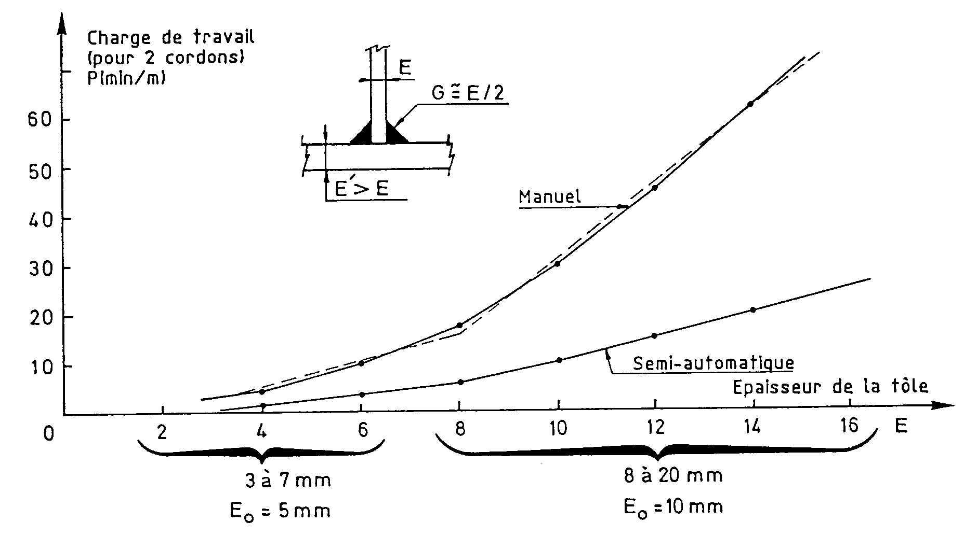
8 to 20 mm
Eo=10 mm
3 to 7 mm
Eo=5mm
Plate Thickness
Semi-Automatic Welding
Manual Welding
WORKING LOAD
(for 2 welds)
P (min/m)

Semiautomatic Welding: P = 2 min/m P = 10 min/m
ΔP = 32% by mm ΔP = 25% by mm
Manual Welding: P = 8 min/m P = 31 min/m
ΔP = 29% by mm ΔP = 20% by mm

Figure 5: Variation in welding manpower according to plate thickness (for two welds).

COST of CONSUMABLES: F_{CONS}

The welding cost per meter (energy, gas, electrodes, provision for the equipment depreciation, ...), excluding manpower, is estimated by Eq.18 (figure 6):
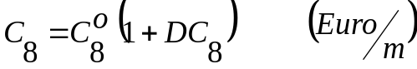 [18]
with C8º = the cost/m of consumables to weld an Eo plate thick (Eo being the reference thickness = ‘Dref’) on a thicker plate (e.g.: to weld a web with its flange). Continuous welds on both sides (double filled) are considered. In the first approximation, the thickness of the weld is fixed at 50% of the thickness of the thinnest plate.
DC8 = Relative change of C8º (cost/m) between a (Eo) and a (Eo + 1 mm) plate thick.

Then the consumable cost is:
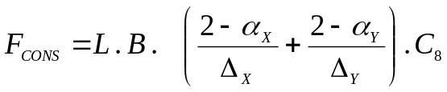 (Euro) [19]

- C8 (C₈⁰), DC8 Consumable Costs (energy, gas, electrodes, provision for the equipment depreciation,...)

C₈⁰ (m-h/m) and DC8 (1/mm)
Format: 2 REAL ; 1 line free format
Ex.: 0.85 0.10 User comment

C8 (C₈⁰) = The cost per m of consumables to weld an Eo plate thick (Eo being the reference thickness = ‘Dref’) on a thicker plate (e.g.: to weld a web with its flange). Continuous welds on both sides (double filled) are considered.
= 1.35 Euro/m according to Rahman (Bengladesh)
= 0.90 Euro/m according to CEWAC with Dref =10mm (Semi automatic welding)
= 1.00 Euro/m according to CEWAC with Dref =10mm (Manual welding)
= 0.25 Euro/m according to CEWAC with Dref =10mm (Semi automatic welding)
= 0.30 Euro/m according to CEWAC with Dref =10mm (Manual welding)

DC8 = Relative change of C8º (cost/m) between a (Eo) and a (Eo + 1 mm) plate thick.
= +0.22 (22%) between 3 and 7 mm : Dref = 5mm, Manual welding (CEWAC 98)
= +0.17 (17%) between 3 and 7 mm : Dref = 5mm, Semi automatic welding (CEWAC 98)
= +0.24 (24%) between 8 and 20 mm : Dref = 10 mm, Manual welding (CEWAC 98)
= 0.30 (30%) between 8 and 20 mm : Dref = 10 mm, Semi automatic welding (CEWAC 98)
= +0.10 (10%) if a large variation of the design variables during the optimization process is expected.

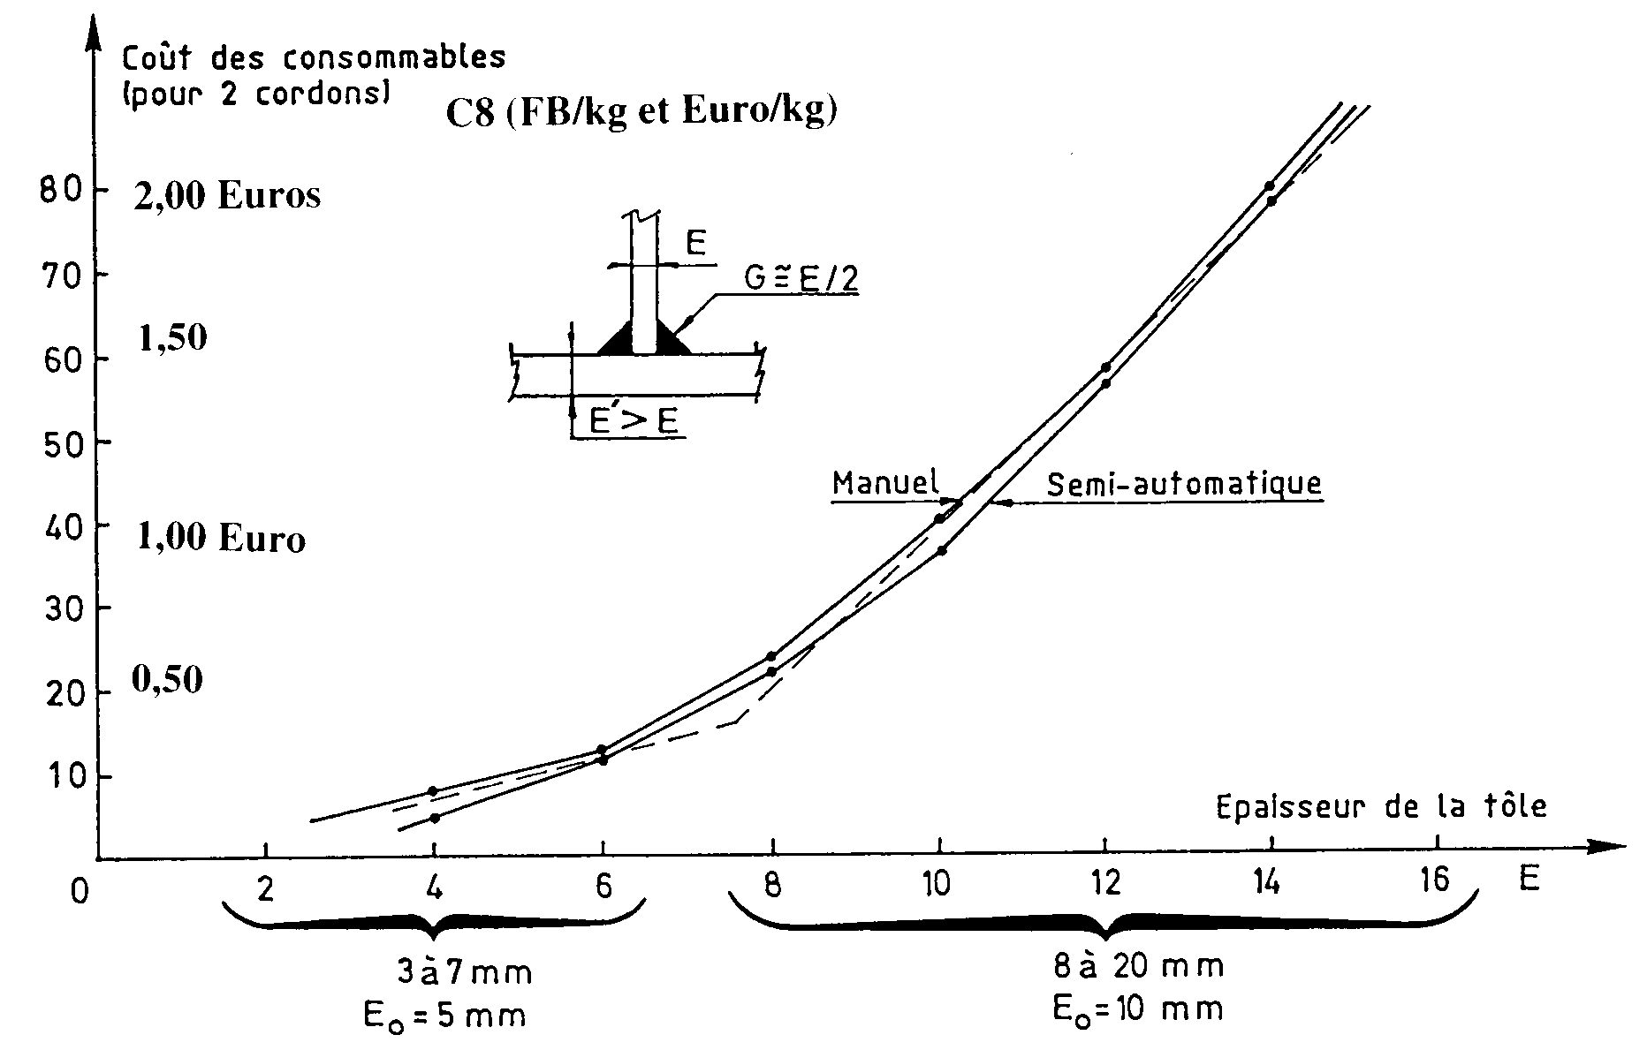
CONSUMABLE COST (for 2 welds)
C8 (BEF/m and EURO/m)
2.00 Euro/m

1.50

1.00 Euro/m

0.50
Semi-Automatic Welding
Manual Welding
Plate Thickness
8 to 20 mm
Eo=10 mm
3 to 7 mm
Eo=5mm

Welding C8º = 10 BEF/m (0.25 Euro/m) C8º = 36 BEF/m (0.90 Euro/m)
semiautomatic: (C8 = 17% by mm (C8 = 30% by mm

Manual Welding: C8º = 12 BEF/m (0.30 Euro/m) C8º = 40 BEF/m (1.00 Euro/m)
DC8 = 22% by mm DC8 = 24% by mm

Figure 6 : Consumable costs for 1 m of welding of a stiffener (two welds).

